**Ring Levels & The CPU**

**Rings of Protection**

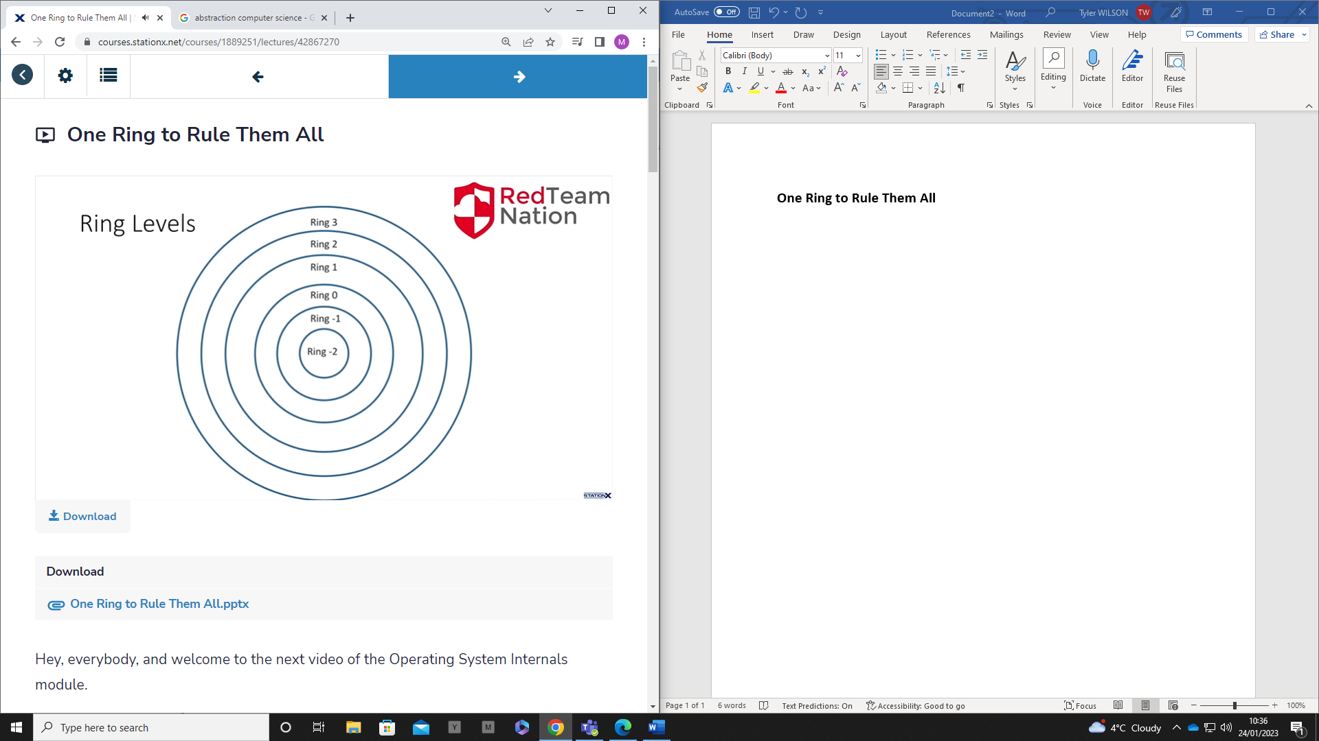

The lower the level, the higher the privilege

* Level -2 has highest privileges and most access

**Level 3**

* Application level
* This is where any user-based applications reside
* Least level of privilege with no direct access to kernel
* Apps can only run specific types of syscalls

**Level 2/1**

* Device drivers sit here
* Not allowed full access at ring level 0 due to the least privilege rule
  + Only provide it the least amount of privileges its required to function
* Drivers need a lot of freedom and control, but not all of it

**Level 0**

* In physical systems, this is the most privileged ring
* All kernel code lives in this ring
* This provides full access to kernel and hardware and everything in between
  + If an attacker can get from level 3 down to level 0, this is a full system compromise and will enable full machine access
  + Privilege escalation

**Level -1**

* Only in virtual environments
* Moving away from the OS itself on to a virtualised OS like a hypervisor or VM
* When a hypervisor is running an OS
  + Virtual box would be accessing Debian at ring -1

**Level -2**

* A special type of ring that allows for System Management Mode
* This allows the CPU to stop all operations of the OS to perform other actions
  + Can be anything from reducing heat physically to chipset errors

**The CPU**

The brain/core of the computer

Small chip with billions of transistors

2 main components:

* **Control Unit**: Handles instructions from memory
* **Arithmetic Logic Unit**: Performs any mathematical and logical operations

**x86**

* x86 was the most commonly used processor to follow up the 16 bit one
* This is also referred to 32-bit
* 32-bit processor cannot run 64-bit apps
* Can only handle 4GB of memory

**X64**

* Now the most common processor used today, 64-bit
* X64 can run x86 applications
  + Can emulate x86
* When working with ASM, the instruction set will be vastly different as well as the way the CPU works
  + Can do same things but will do it differently
* Can handle up to 32GB of memory